tourGuide: A tourism site.

By- Adarsh Singh Tiwari(11711793)

Ronak (11709771)

Github: <https://github.com/rnadarsh25/tourGuide-Web-Design-Project/tree/master/tourguide>

Aim of the Project:

* The Aim of this project is to make a website to provide an easy and cheap platform for people who want to travel and to explore more deep in this world.
* The Outcome of this project is that a person can easily check the whole descriptions and details of any particular place.

Technology used:

HTML:

Hyper Text Markup Language (HTML) is the main markup language for creating [web pages](http://en.wikipedia.org/wiki/Web_page) and other information that can be displayed in a [web browser.](http://en.wikipedia.org/wiki/Web_browser) HTML is written in the form of [HTML](http://en.wikipedia.org/wiki/HTML_element) [elements](http://en.wikipedia.org/wiki/HTML_element) consisting of tags enclosed in [angle brackets](http://en.wikipedia.org/wiki/Angle_brackets) (like <html>), within the web page content.

CSS:

Cascading Style Sheets (CSS) is a [style sheet language](http://en.wikipedia.org/wiki/Style_sheet_language) used for describing the [presentation](http://en.wikipedia.org/wiki/Presentation_semantics) [semantics](http://en.wikipedia.org/wiki/Presentation_semantics) (the look and formatting) of a document written in a [markup language.](http://en.wikipedia.org/wiki/Markup_language)

JavaScript:

JavaScript® (often shortened to JS) is a lightweight, interpreted, object-oriented language with [first-class functions](https://en.wikipedia.org/wiki/First-class_function), and is best known as the scripting language for Web pages, but it's used in many non-browsers as well.

**JQuery:**

jQuery is a lightweight, "write less, do more", JavaScript library.

The purpose of jQuery is to make it much easier to use JavaScript on your website.

jQuery takes a lot of common tasks that require many lines of JavaScript code to accomplish, and wraps them into methods that you can call with a single line of code.

HomePage:

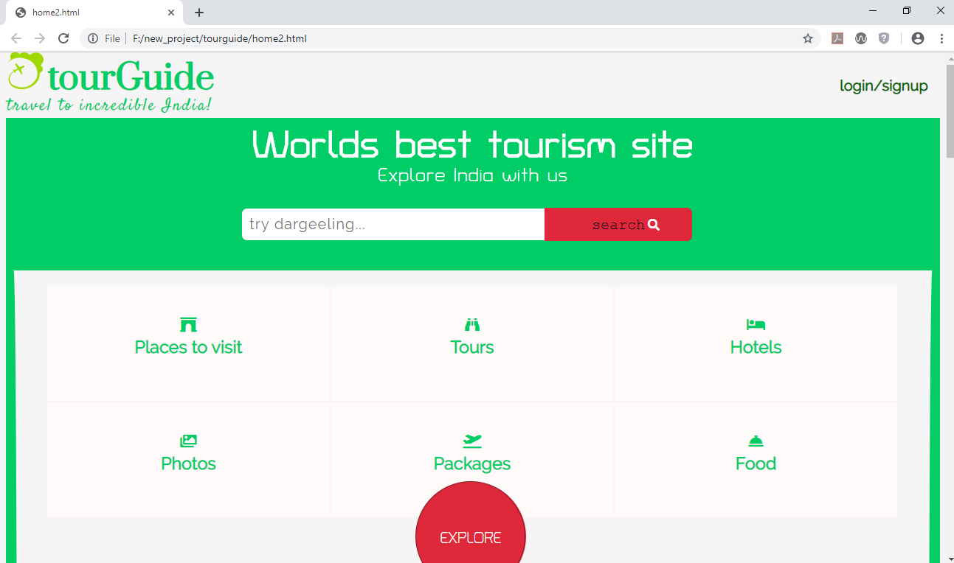

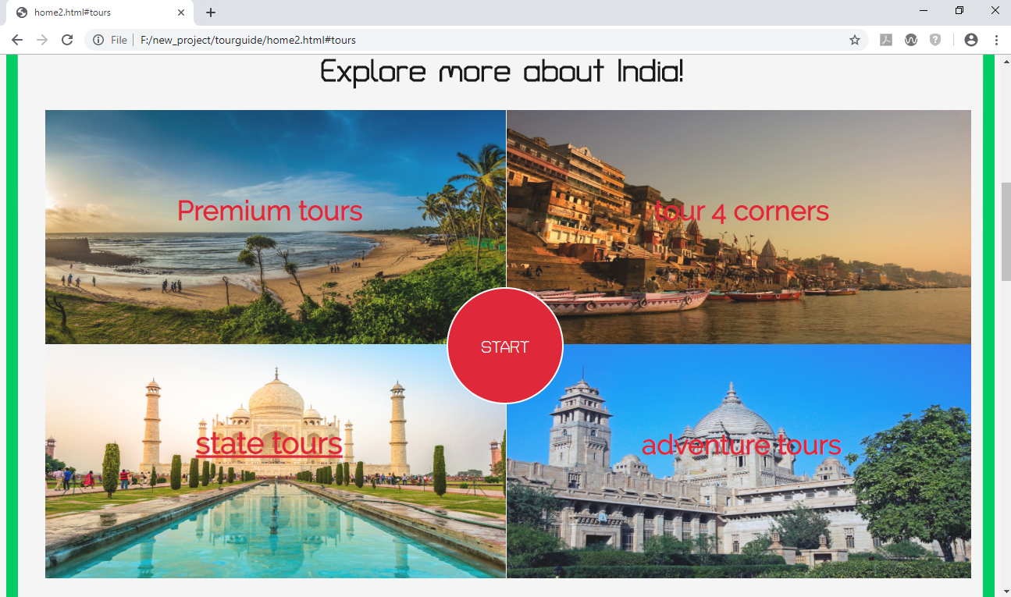

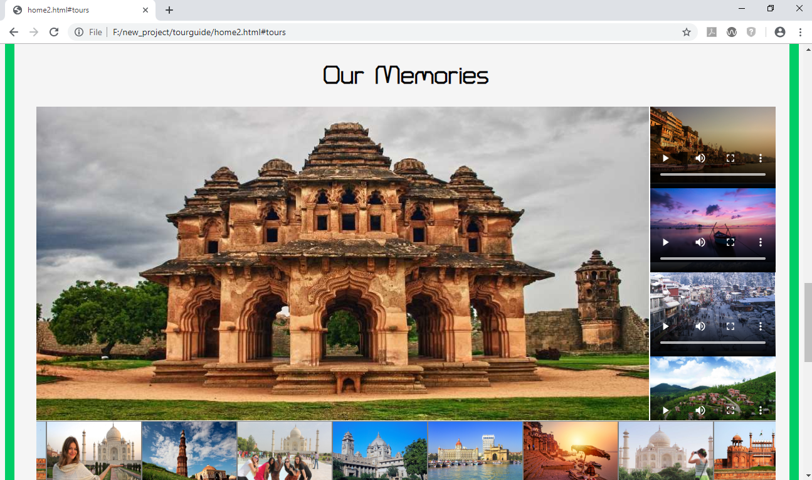

Tour package page:

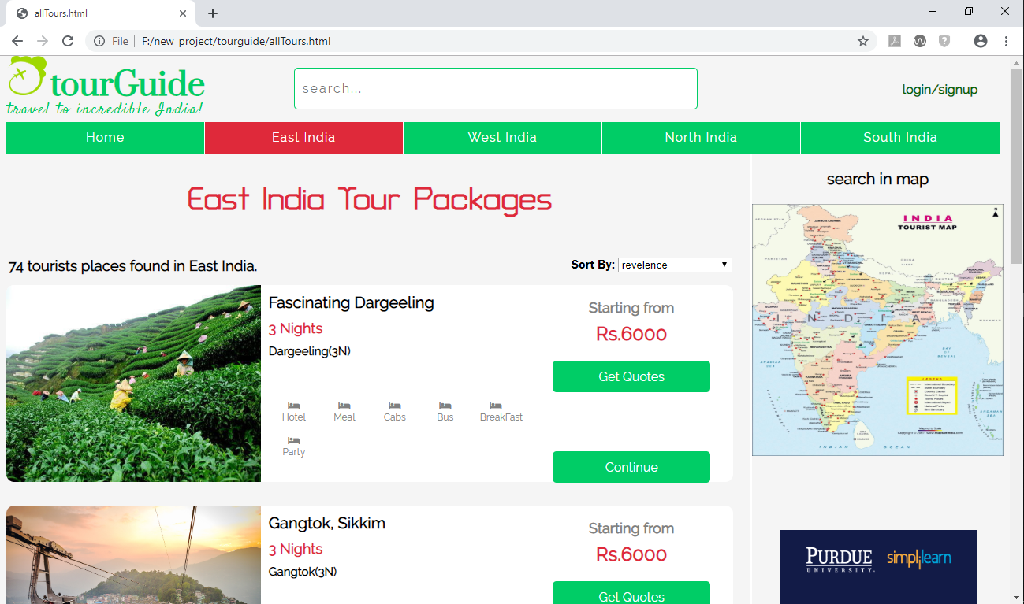

Detail Page:

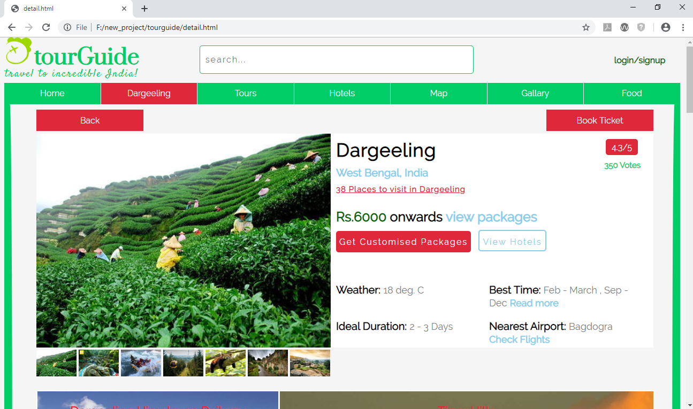

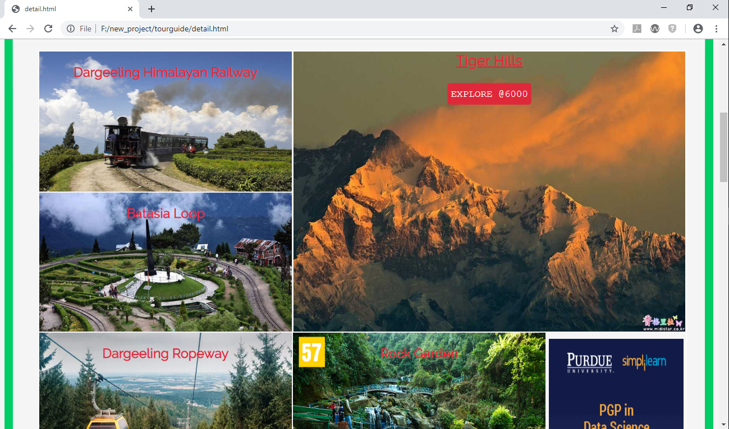

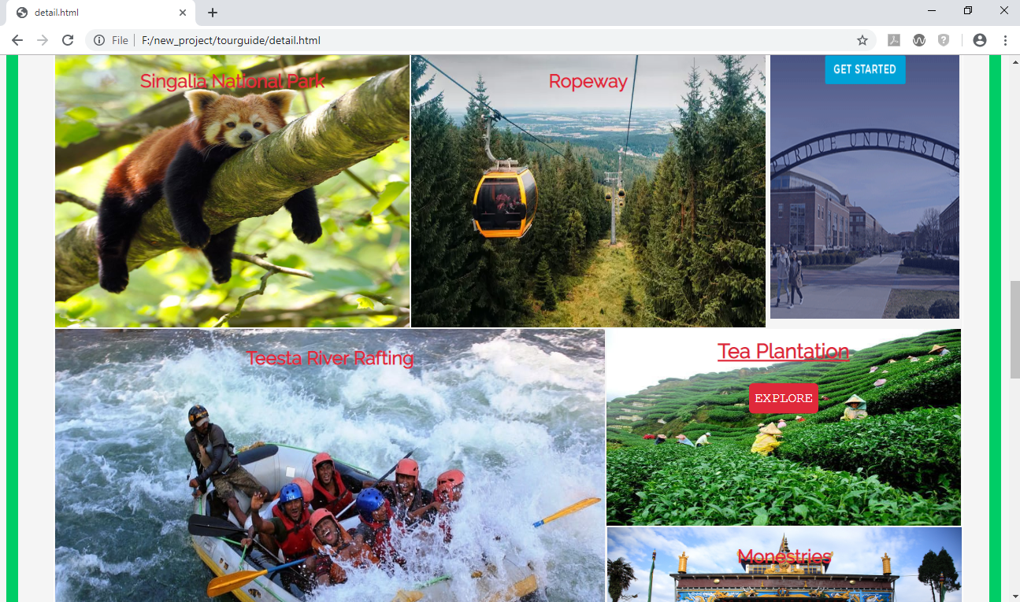

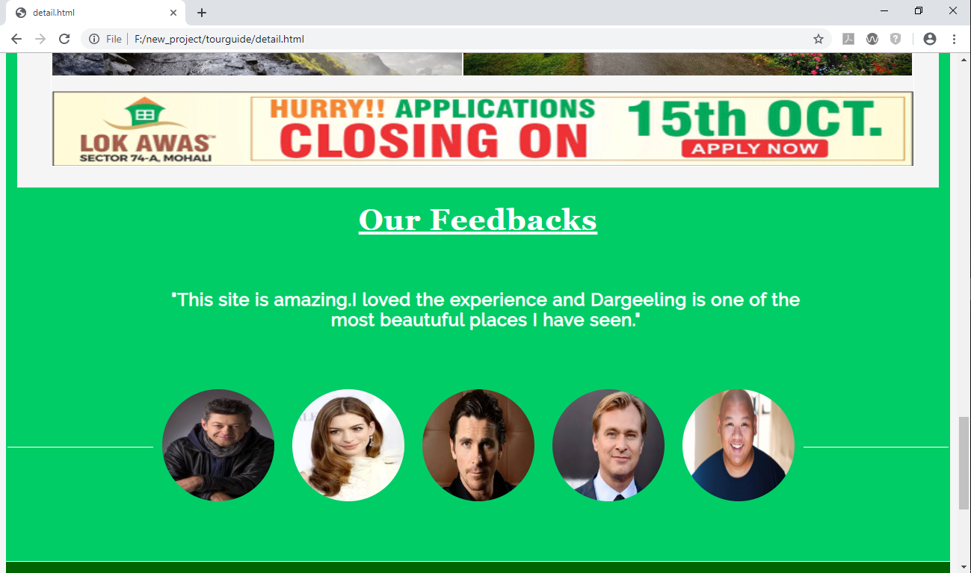

Description Page:

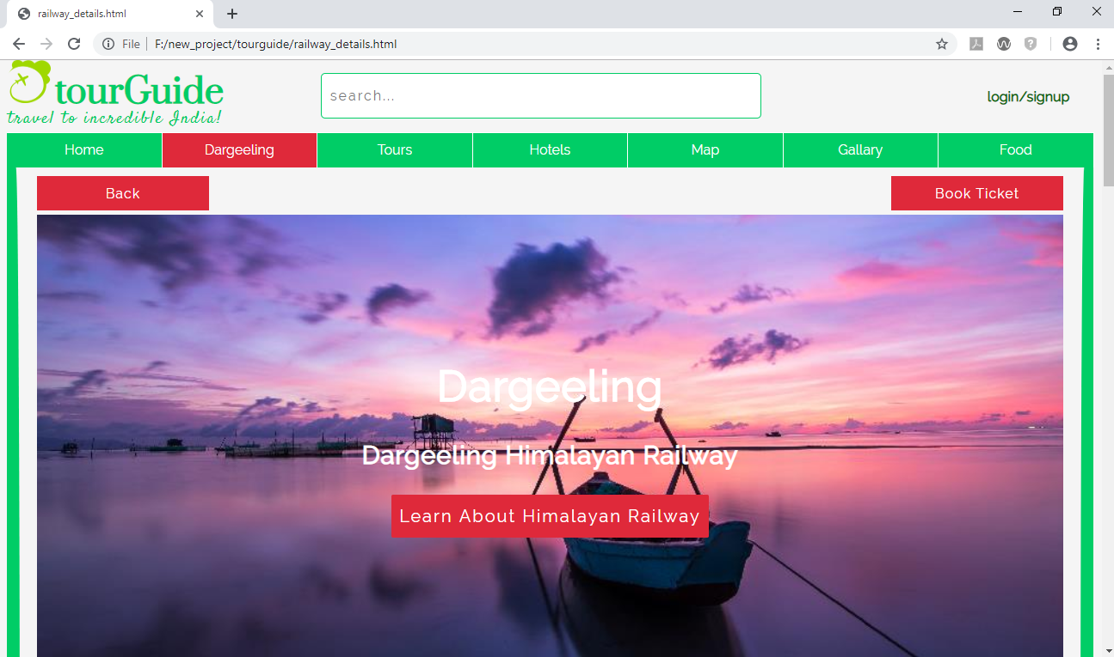

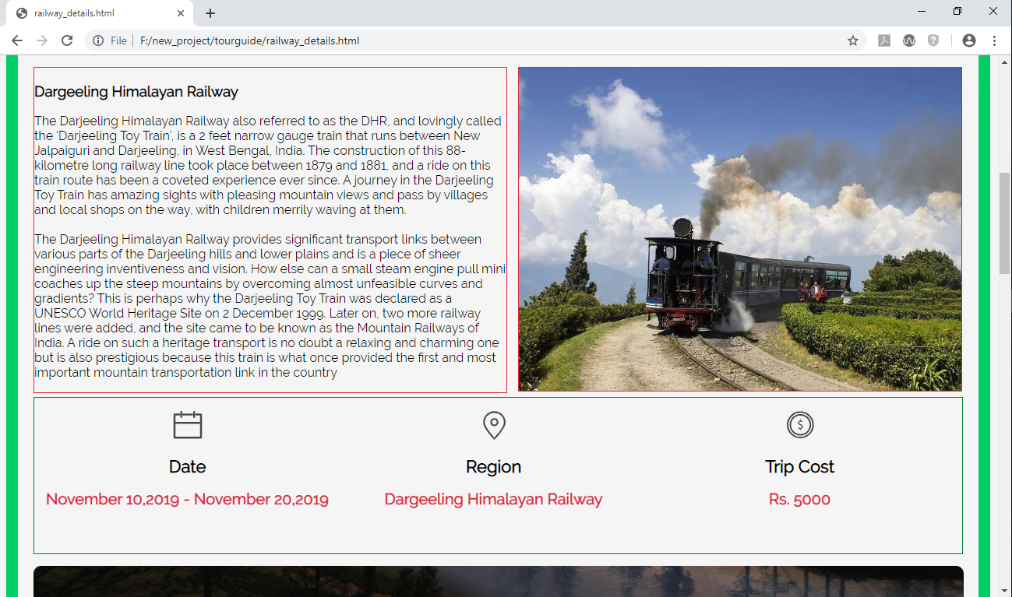

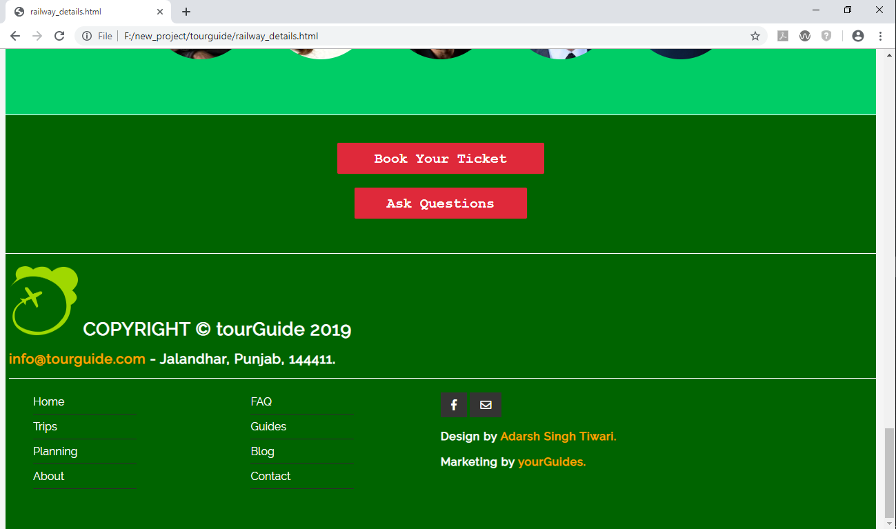

Book Ticket:

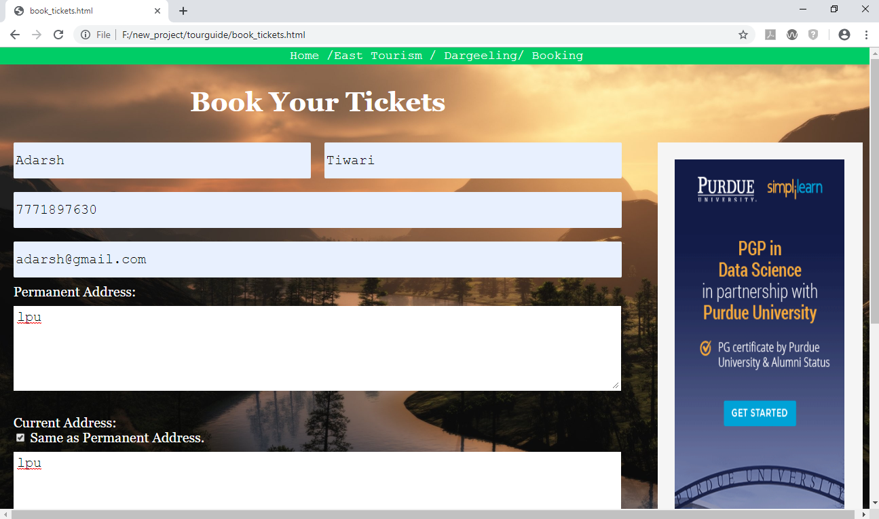

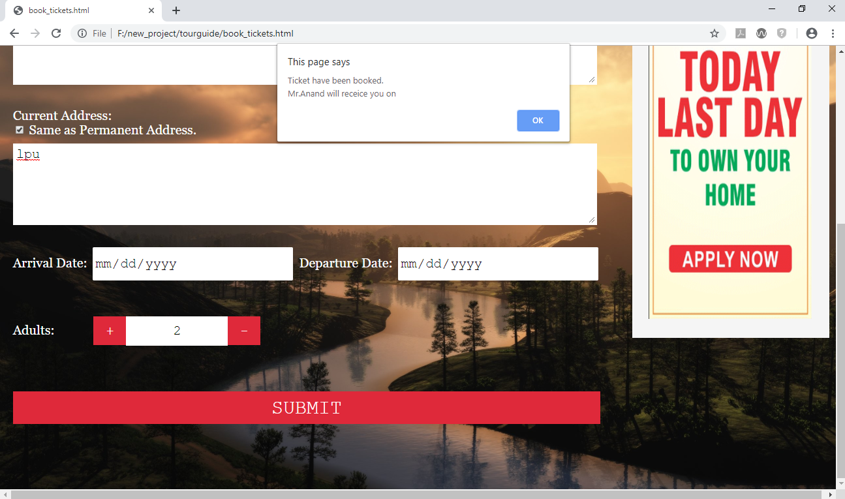

Login Page:

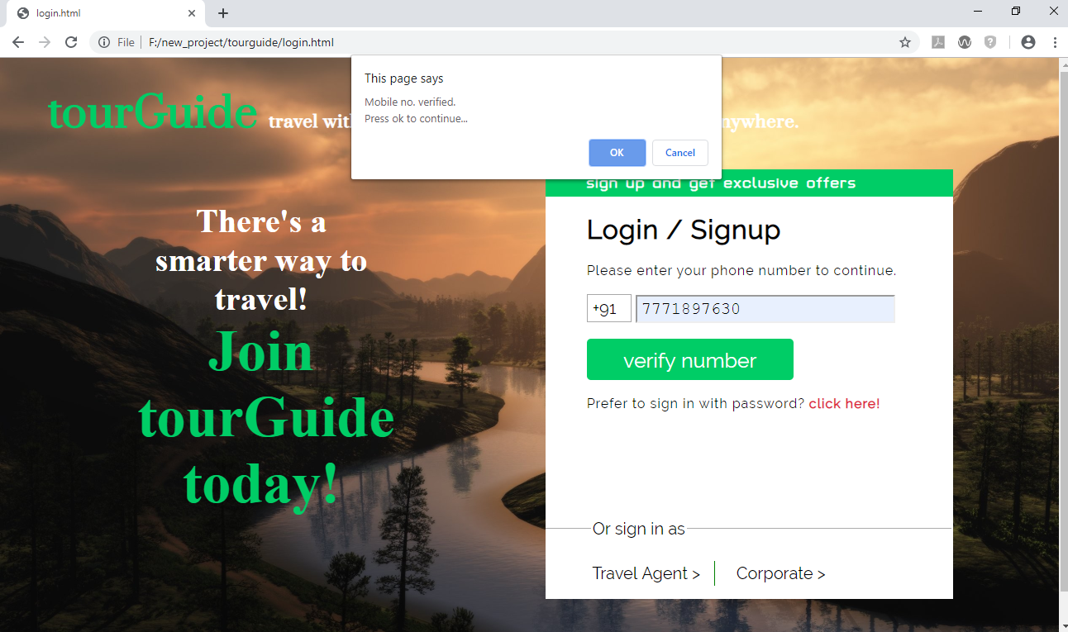

Hotel Page:

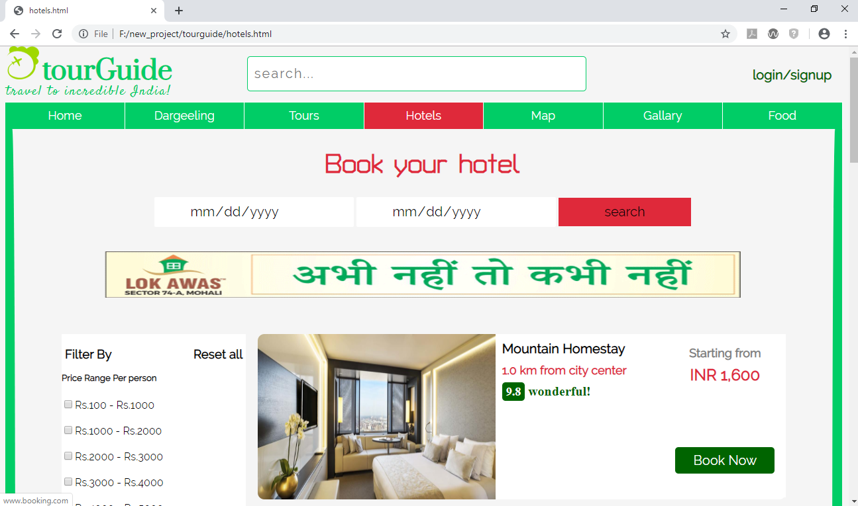

Restaurant Page:

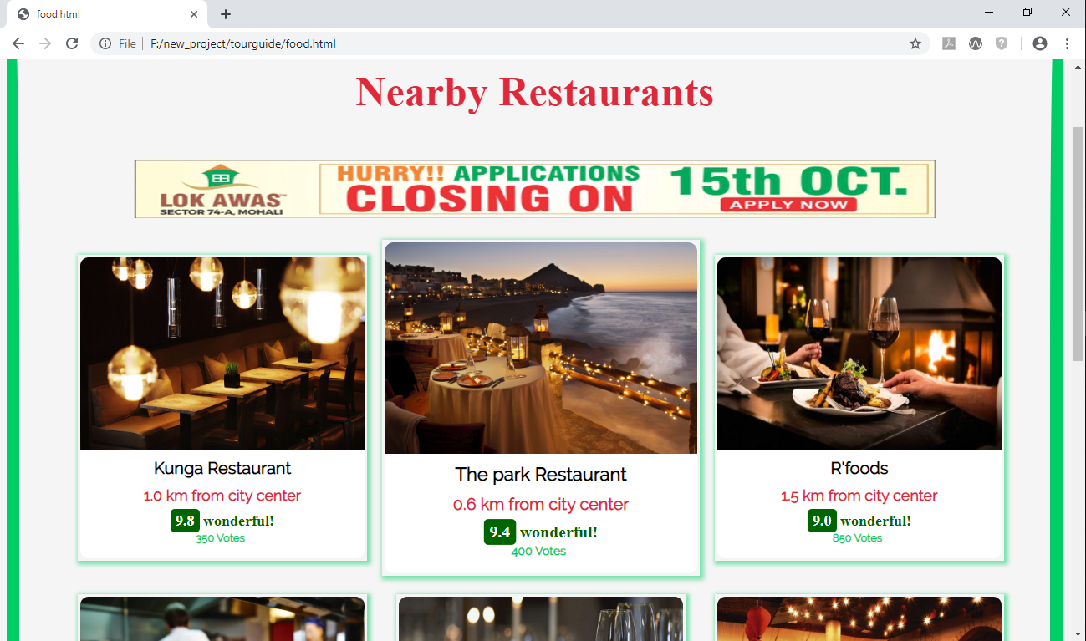

Gallery Page:

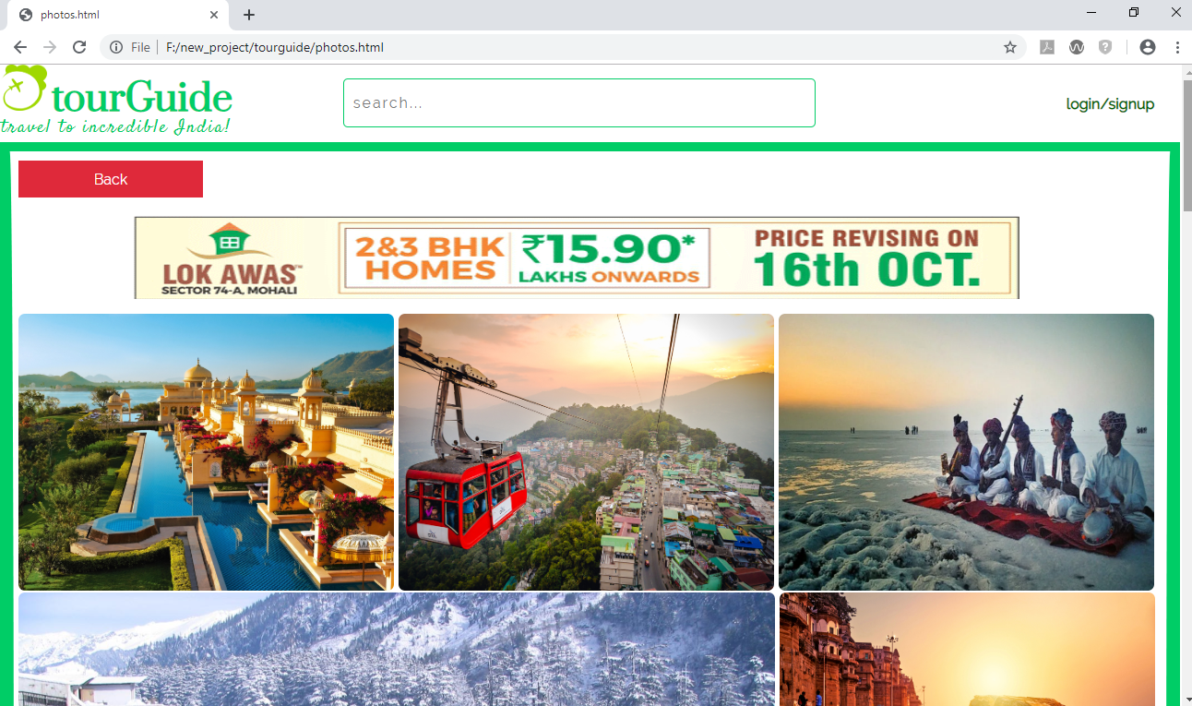

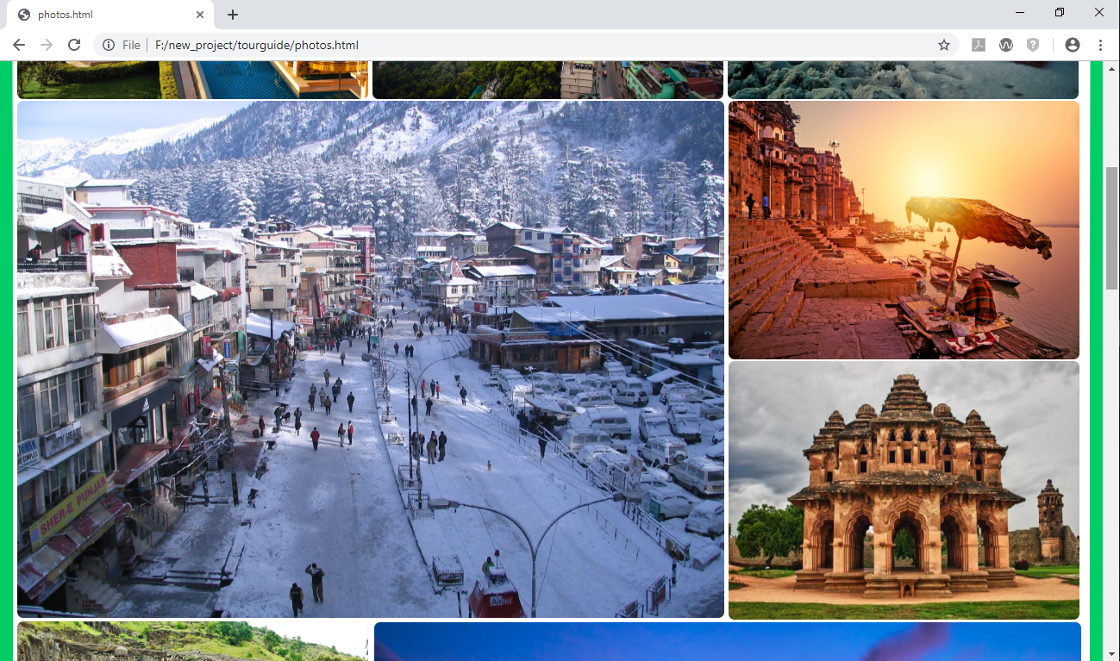

Copyright:

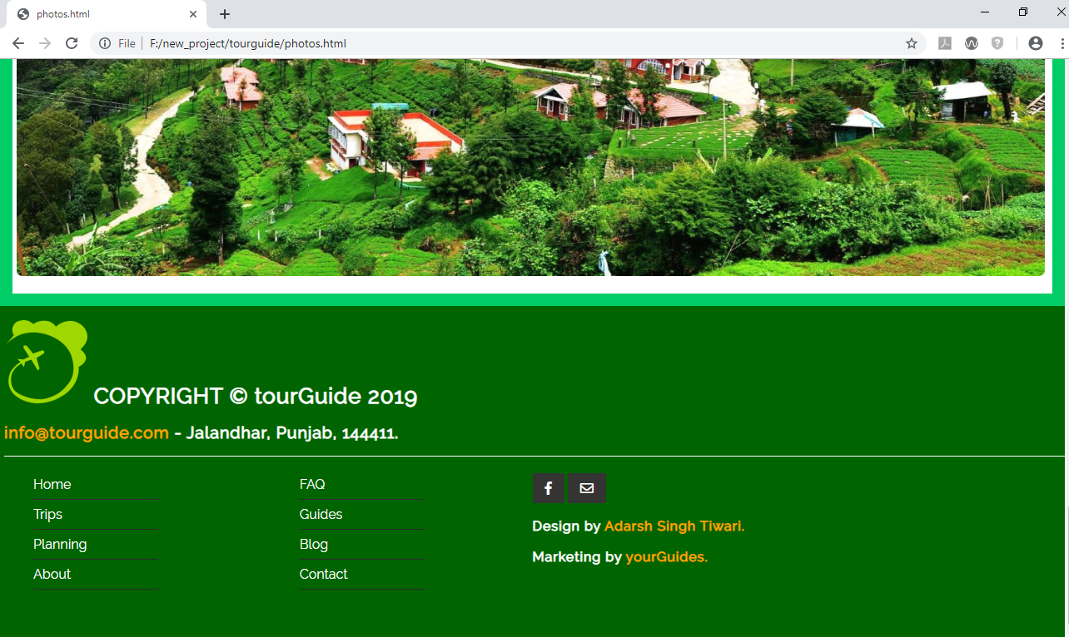

Thank You ☺

“You cannot inspire others until you become your own inspiration.” -Ast.